Once I got this: “Feasible dataset not drawn in this attempt - please hit the redraw button.”. There is no “redraw button”, so I guess I had to end that session.
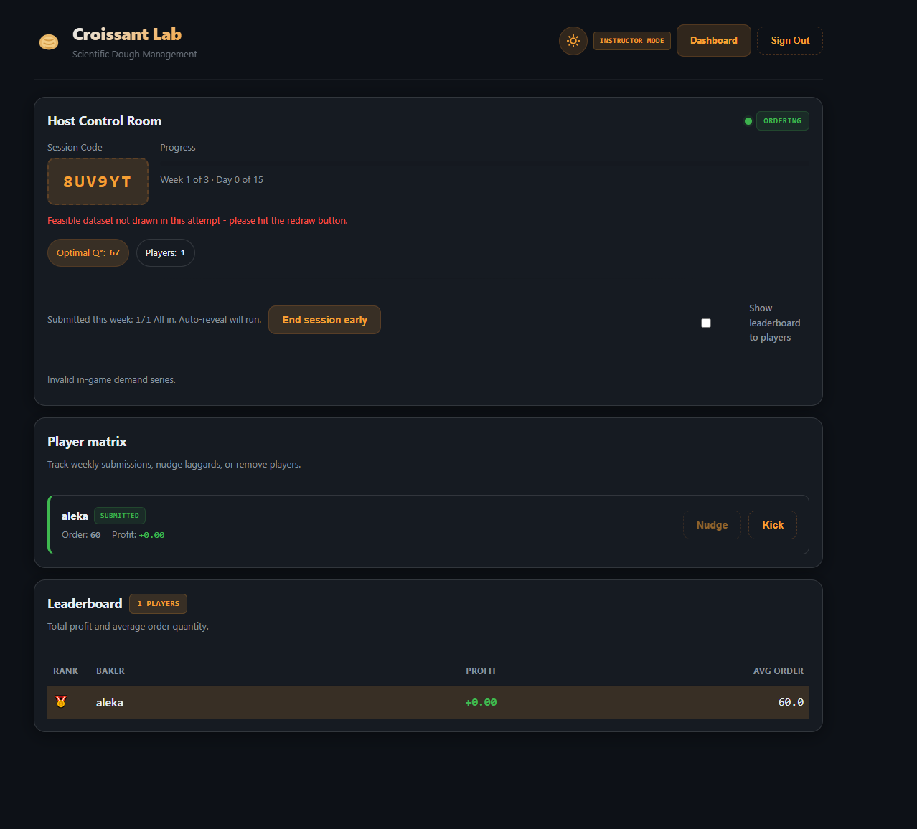

The problem: The issue was that as an instructor I choose too few weeks (3 weeks) and that issued a problem. The demand generator tries to find a random dataset that closely matches the target distribution (mean, std, skewness, kurtosis). It runs 5,000 attempts with strict tolerances, then 8,000 with looser ones. If none pass, it returns empty arrays — which is the broken state you saw. With only 3 weeks (15 game days), the small sample makes it very hard to satisfy all the statistical criteria simultaneously.
The fix: Instead of returning empty arrays when nothing passes the tolerance checks, it now tracks the best-scoring candidate across all 8,000 fallback attempts and returns that one. So you always get a valid dataset — it just might not be statistically perfect, which is fine for gameplay.
I fixed it by updating the following file:
functions\src\demand.ts
Then hit rebuild and redeploy:
npm run build:functions
npm run deploy:functions
After that, "Create Session" will always produce a valid demand dataset regardless of the parameters you choose.

FIXES
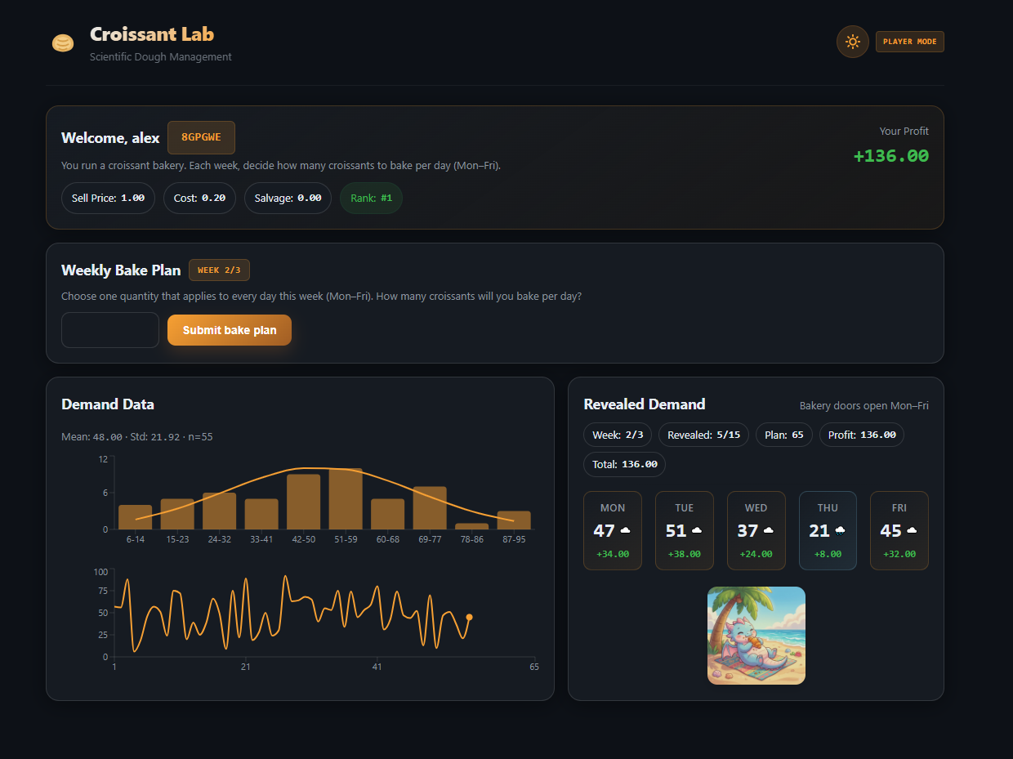

Top plot — Histogram: Shows the frequency distribution of all demand observations so far (n=55, which is the 50 training samples + 5 revealed days from Week 1). The x-axis is demand ranges (bins), the y-axis is how many days fell in each range. The orange curve is the fitted normal distribution. You can see demand is roughly bell-shaped, centered around 42–59, with occasional very low or high days.
Bottom plot — Time series: Shows demand day-by-day in chronological order. The x-axis is the day number (1 through 65), the y-axis is the actual demand that day. The first 50 points are the training data given to you at the start. The last 5 (after the gap/dot) are the revealed demand from Week 1 — the actual days you just played. This helps you see the volatility and whether there are any trends (there shouldn't be — it's random draws from a fixed distribution).
Together they help the player understand: the demand is noisy but stable around the mean, and the smart move is to keep ordering near the critical fractile (~67) rather than reacting to individual good or bad days.

FIX: Add description on x and y axis. Also past data at the bottom should be shown e.g. in green and all new data should be with that yellow color. Also, show on the x-axis text for each phase, e.g. “past data”, “week 1”, then “week 2” etc (corresponding on the associated days).

I updated these two files:
src\components\TrainingChart.tsx
src\pages\PlayerGame.tsx

Then test with npm run dev and check localhost:5173. You should see:
- Histogram: "Demand range" on x-axis, "Frequency" on y-axis
- Time series: "Demand" on y-axis, phase labels ("Past data", "Week 1", "Week 2"...) on x-axis
- Green line for past/training data, yellow/orange line for revealed game data
- Dashed divider between the two phases
- Subtle background shading to distinguish phases
When happy, deploy with npm run deploy:hosting.

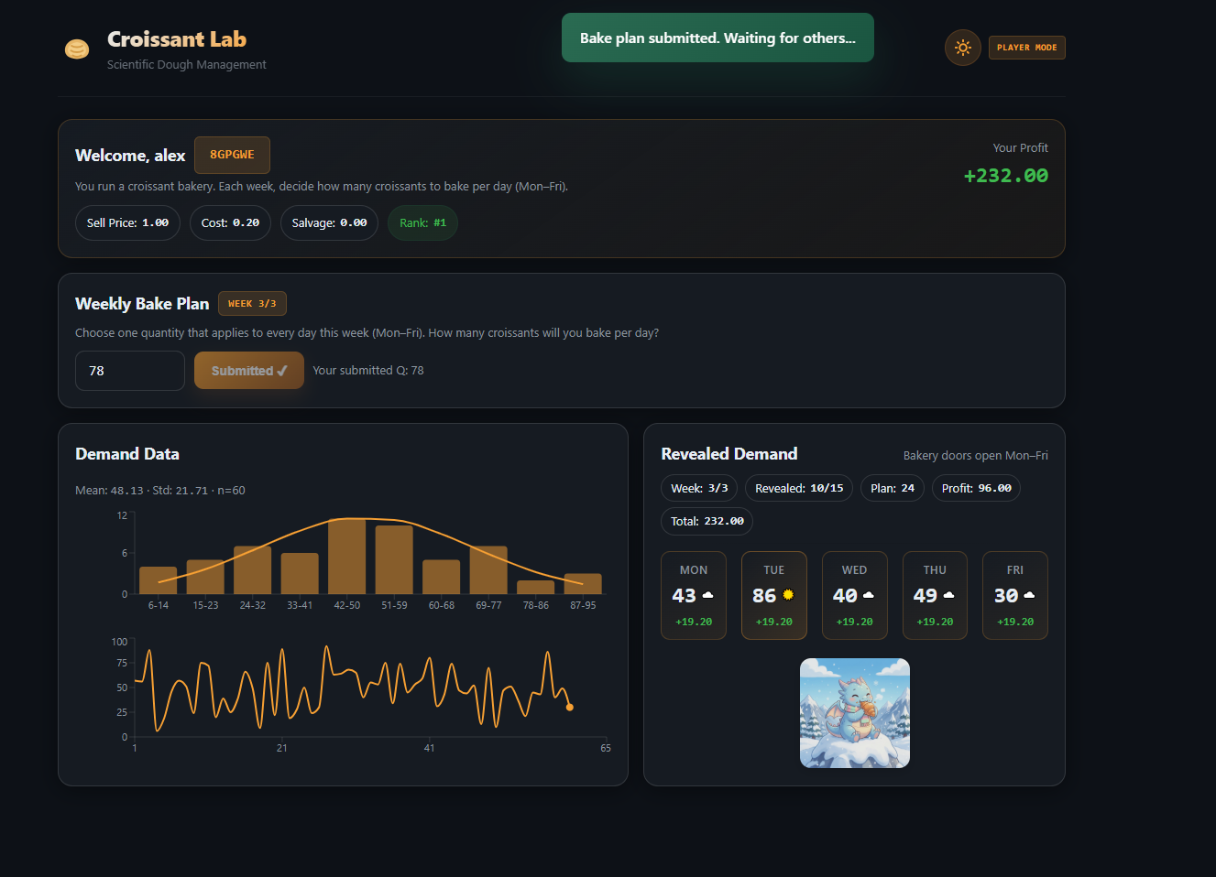

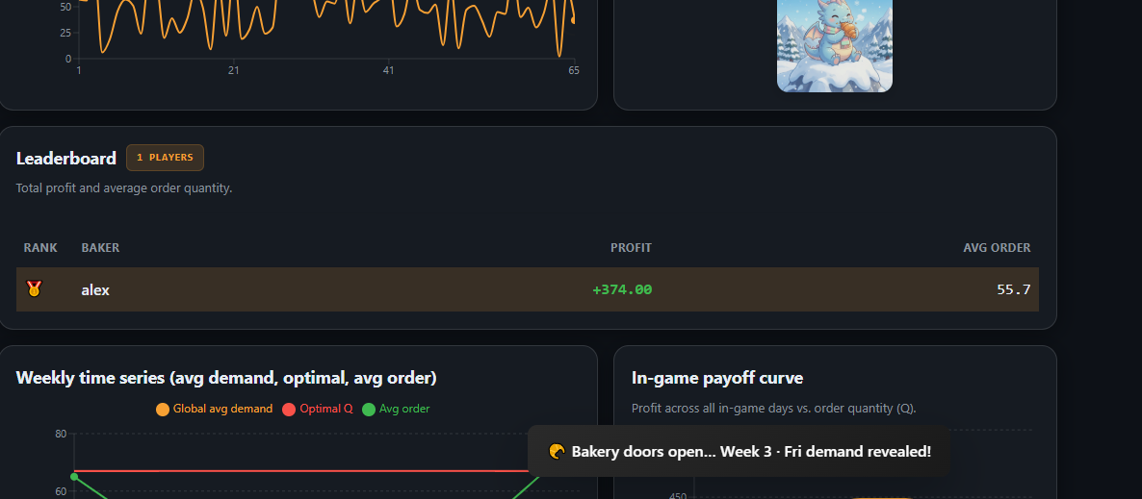

Add description

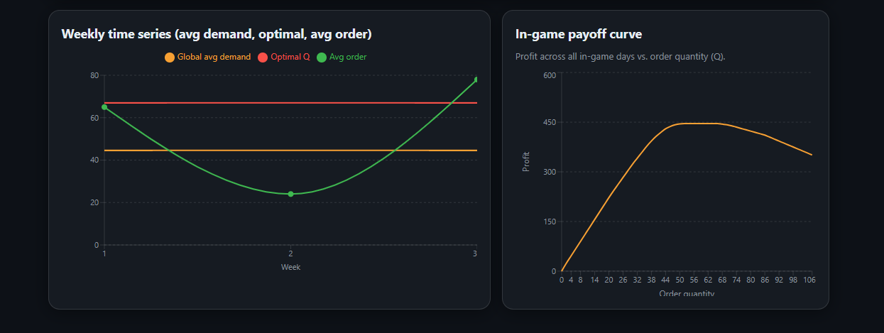

FIX on instructor dashboard:
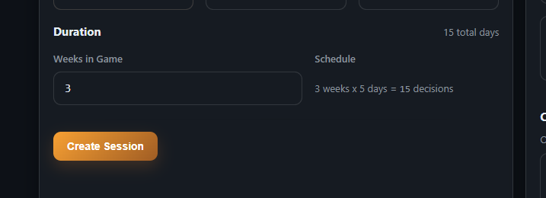

Actually what we decide is fixed per week, so there are only 3 decisions but for 15 days.
SOLUTION:
Two files to replace:
Host.tsx → src\pages\Host.tsx (frontend):
- Schedule text now reads: "3 weeks x 5 days = 3 decisions, 15 days"
- Delete button added to active sessions (next to End)
- Confirmation message updated for any session
index.ts → functions\src\index.ts (backend):
- Removed the restriction that only finished sessions can be deleted — now you can delete sessions in any state
For this change you need to deploy both frontend and functions:
bash
npm run deploy
This will let you clean up all those test sessions with invalid demand series.

I am not able to delete several test sessions:
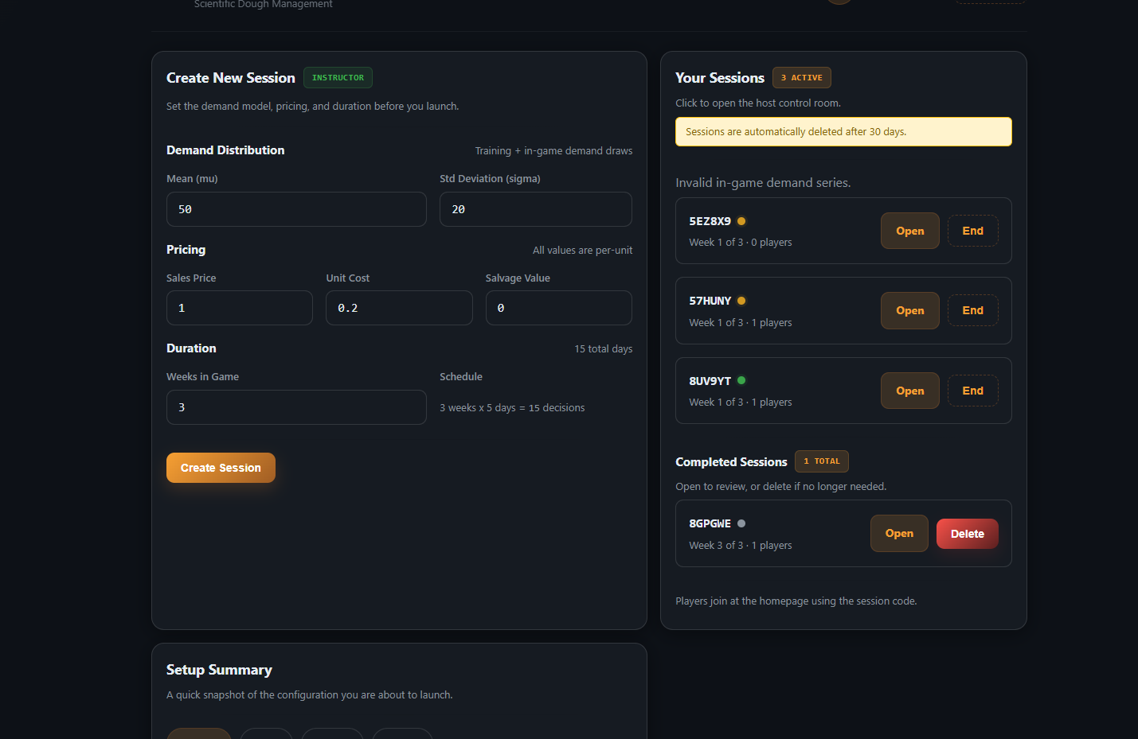

This message should be shown at the center of the screen: 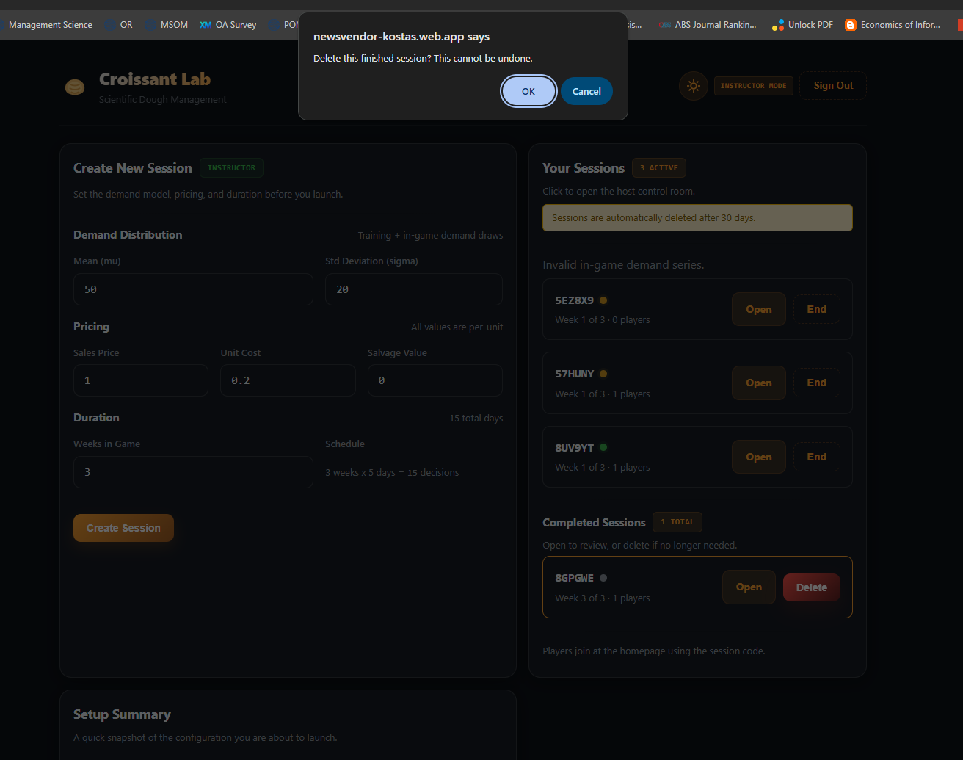

Once instructor creates a session, the session should automatically start. Why waiting to see how many students will sign up?

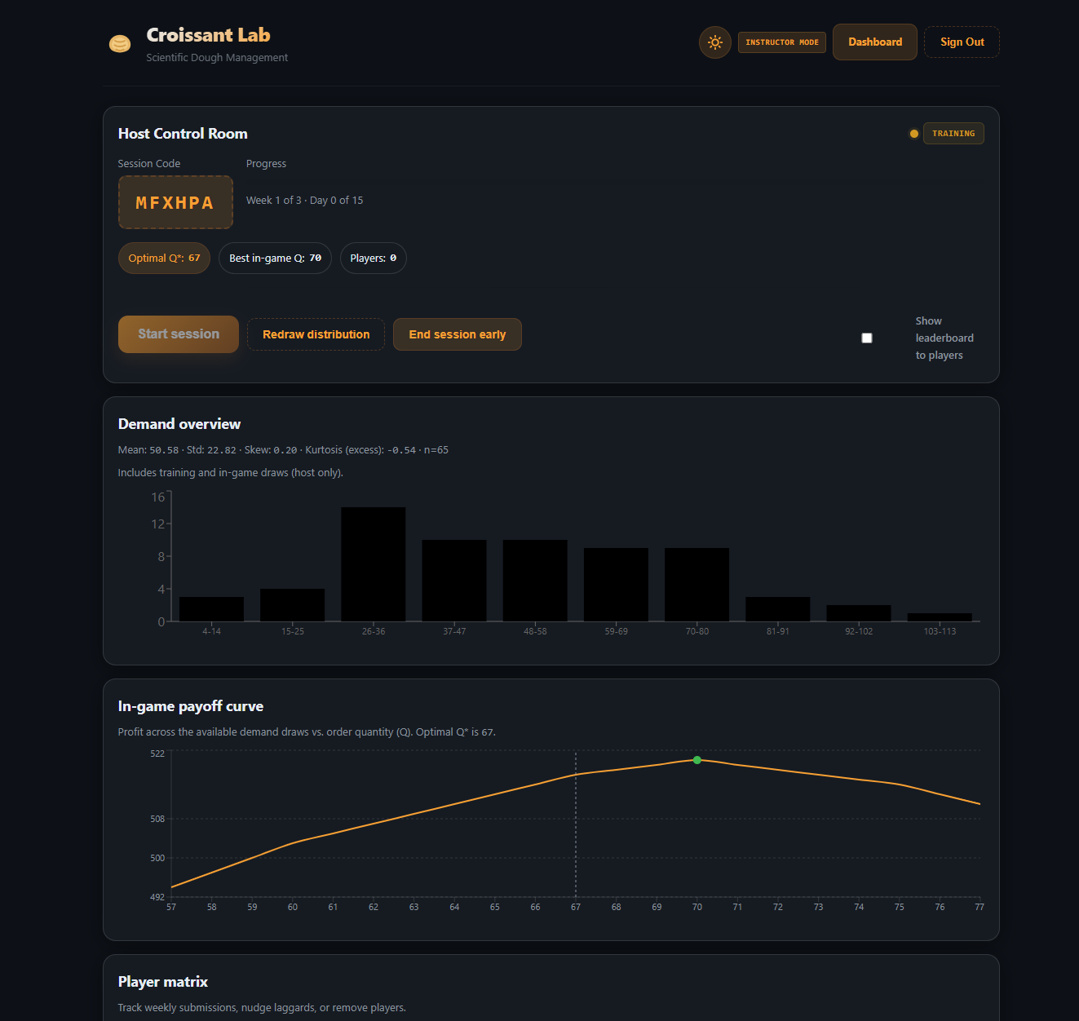

ISSUE:
Once player Alex submits their Q*, the game only proceeds once all players have also chosen their Q*. This is bad and has to be fixed asap.
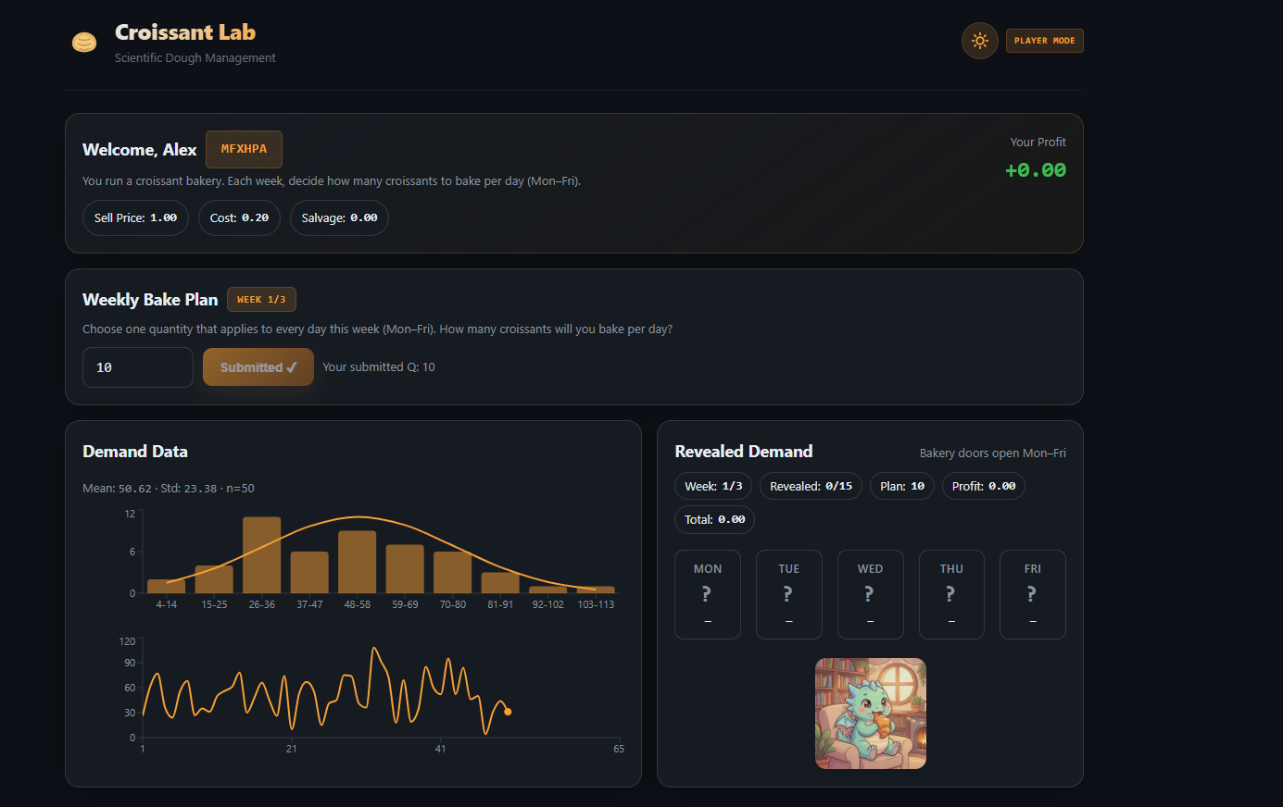

ISSUE:

This message at the bottom is easy to miss, center it at the main page, and should last more seconds so that people do read it!

Solution:
Two files to replace:
Host.tsx → src\pages\Host.tsx:
- Delete/End confirmations now use a centered modal instead of the ugly browser confirm() dialog
- Modal has Cancel and Confirm buttons, styled consistently with the app
PlayerGame.tsx → src\pages\PlayerGame.tsx:
- "Bake plan submitted" is now a large centered overlay with a ✅ icon, bold text, and a "Waiting for other players..." message — impossible to miss
- Duration increased from 4 seconds to 8 seconds
- Overlay fades in/out with a spring animation
Test with npm run dev, then deploy with npm run deploy:hosting (and deploy:functions too since you still need the delete fix from earlier).

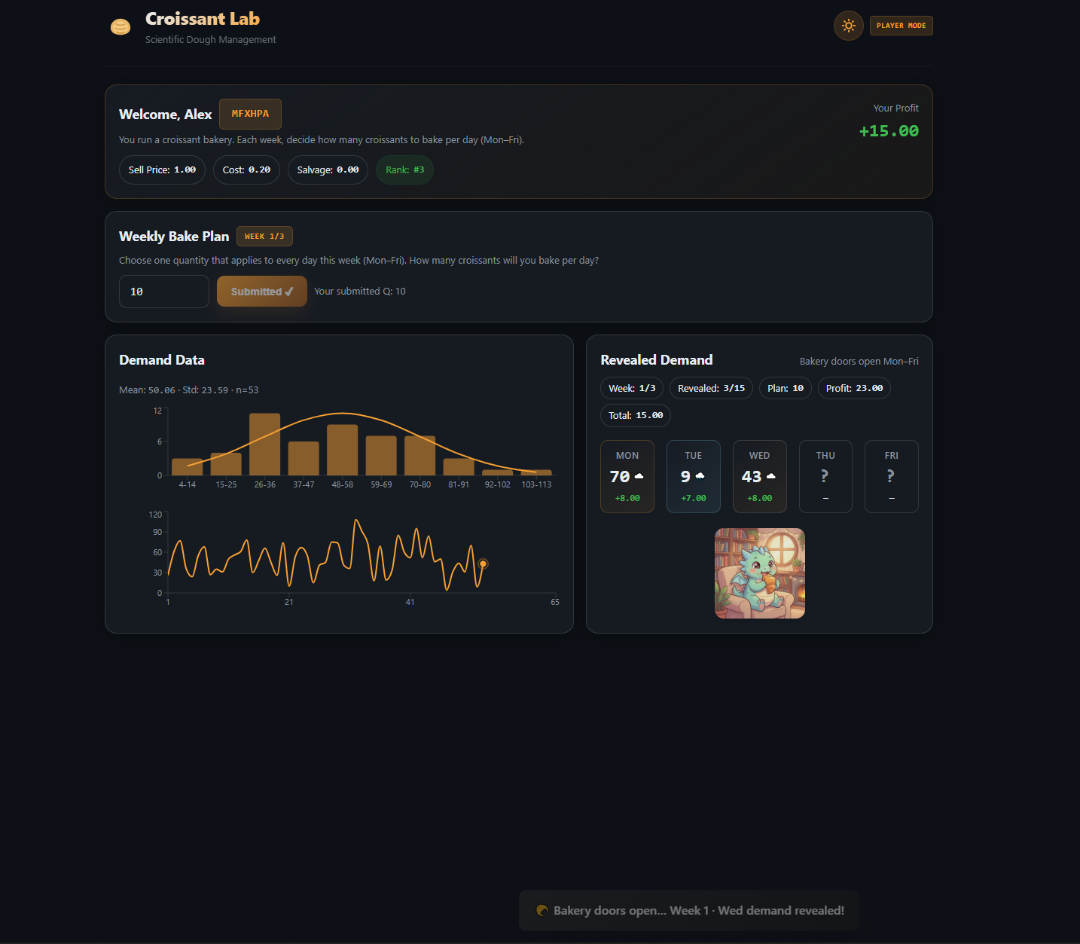

Leaderboard rank should say more information on their per period decisions, demand and profit. Then also say 1st, 2nd, 3rd, no emoticons there.
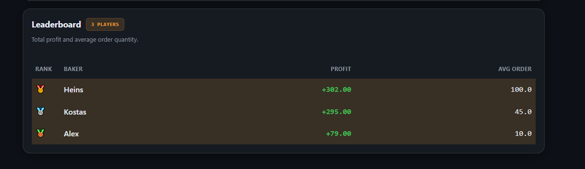
Solution:
Three files to replace:
Leaderboard.tsx → src\components\Leaderboard.tsx:
- Ranks now show "1st", "2nd", "3rd", "4th" etc. — no emojis
- Clickable rows — click a player to expand and see their per-week breakdown
- Expanded view shows a sub-table with Week number, Order Qty, and Week Profit for each week
index.ts → functions\src\index.ts (backend):
- Leaderboard rows now include ordersByWeek and profitsByWeek arrays so the frontend has per-week data to display
types.ts → src\lib\types.ts:
- Added ordersByWeek? and profitsByWeek? to the LeaderboardRow type

Download and replace src\components\Leaderboard.tsx. This version:
- Shows "1st", "2nd", "3rd", "4th" etc. — no medal emojis
- Click any row to expand and see per-week breakdown (Order Qty + Week Profit)
- Shows "Avg Order" column
Also make sure you already replaced src\lib\types.ts with the updated version (adds ordersByWeek and profitsByWeek to LeaderboardRow). If not:
Clarified replacement specifications for leaderboard display
Presented file
Let me give clear instructions on what to replace.
Done
Replace both files:
- Leaderboard.tsx → src\components\Leaderboard.tsx
- types.ts → src\lib\types.ts

AFTER my solution:
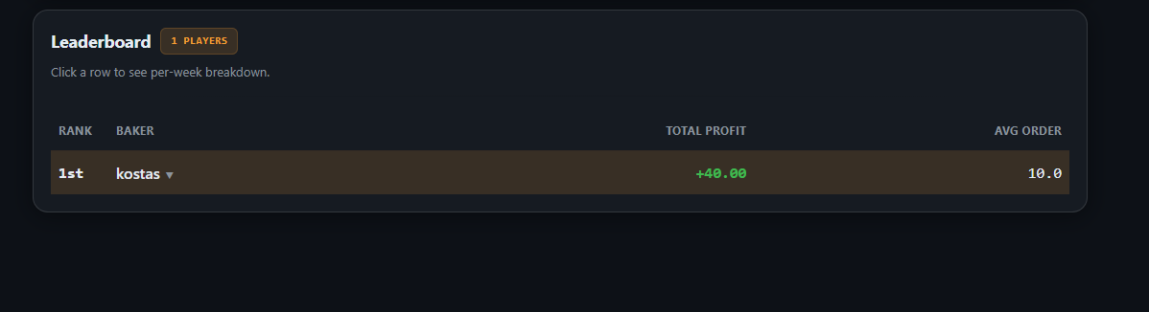
and
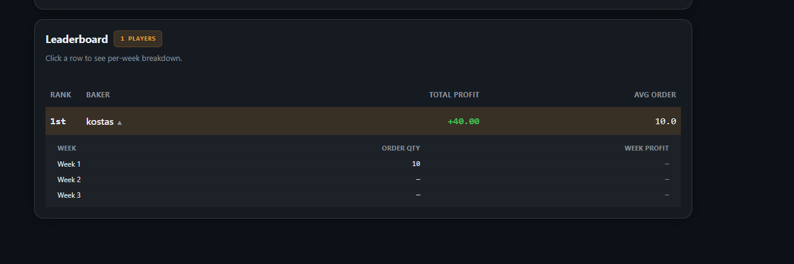

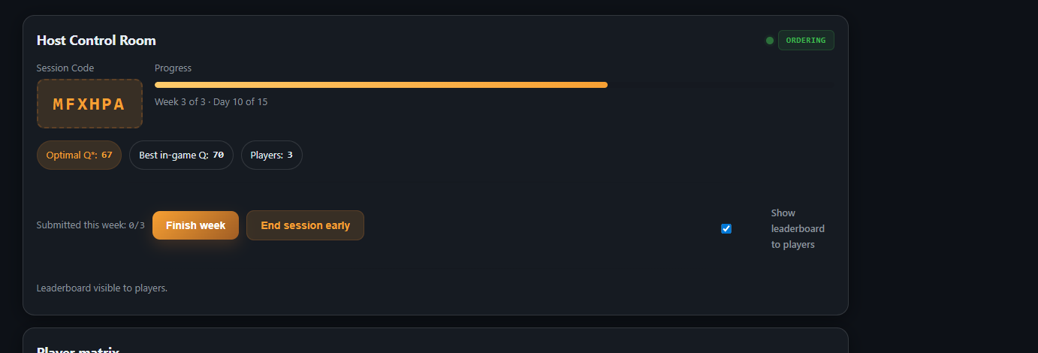
Here's what each element does:
"Finish week" — Forces the current week to end, even if not all players have submitted. Useful in class when someone is slow or absent. It auto-submits a default order for anyone who hasn't decided yet.
"End session early" — Stops the entire game before all weeks are played. Useful when you're running out of class time.
"Show leaderboard to players" — When checked, players can see the live rankings. You might want to hide it early and reveal it at the end for dramatic effect.
Optimal Q*: 67 — The theoretically optimal order (only visible to the host, not players). Best in-game Q: 70 — The order quantity that would have actually maximized profit on the specific demand draws in this session.
As for simplifying — I wouldn't remove any of these. They're all useful for classroom management. The "Finish week" and "End session early" buttons are essential when you have 50+ students and need to keep things moving. The blog post specifically mentions how important it is for instructors to have this flexibility.
What you could simplify is the display — for example, hiding "Optimal Q*" and "Best in-game Q" behind a toggle so the host screen looks cleaner during the game and you only reveal them during the debrief.

ISSUE: Week should have 7 days not 5. Also, show little vertical lines on the x-axis for each day of the Week 1, Week 2 etc. Further, show the past data in dashed line and make the vertical dashed line more distinct to show past data and new data. Also, title on the y-axis of bottom plot should be "Realized Demand"

NOTE: the game is designed around 5-day weeks (Mon–Fri), and the Cloud Functions generate demand data in multiples of 5. Changing to 7 days would break the backend logic (session creation, demand generation, profit calculation all use weeks * 5).

Download and replace src\components\TrainingChart.tsx. The PlayerGame.tsx from before is still correct — no changes needed there.
Here's what changed:
- Past data line is now dashed green (was solid green)
- Divider between past data and game data is now stronger — thicker (#888, strokeWidth 1.5, "6 3" dash pattern) so it clearly separates the two phases
- Small tick marks on the x-axis for each individual day within Week 1, Week 2, etc.
- Lighter dashed dividers between weeks (Week 1 | Week 2, etc.)
- Y-axis label changed from "Demand" to "Realized Demand"

FIXED LIKE THIS:

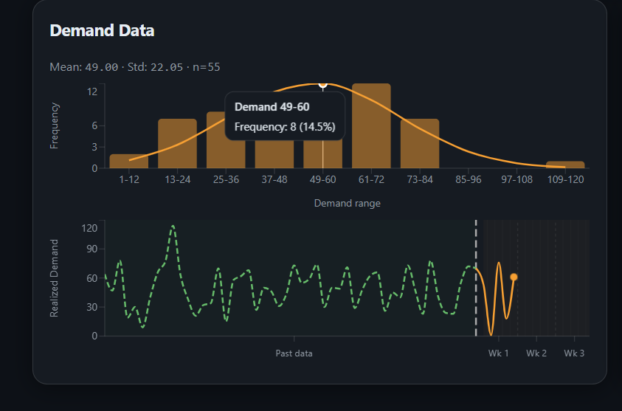

ISSU: change "revealed" to "realized"
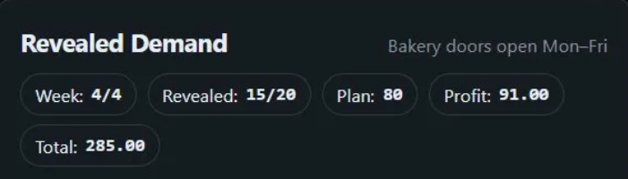

Download and replace src\components\RevealTheatre.tsx

